China Arts
Name
Course Title
institution Affiliations
Date

Introduction
This paper is going to discuss different arts that are found in five regimes: imperial rule in the late Qing; the Republican era; a period of guidance and support by the USSR; the Cultural Révolution; and the Reform era. The Chinese scholars of the global community ruled the western countries in the last years of the Qing dynasty bringing forefront modern technology. This caused some of the Chinese cultural writers to notice that the Chinese culture was so unalterably backwards such that China could not have any hope in featuring in the modern world. However, others still believed that the culture of China had some unique values which must be preserved in all means while others still sought to adjust the Chinese arts so as to brand the country viable into the contemporary world. This diverse opinion expanded the art domain, a period which created a dizzying range of theoretic and beautiful inventions in China. Different writers came up with visual artworks which expressed the changes in social and political values throughout the different regimes and periods.
IMPERIAL RULE IN THE LATE QING
Shijiazhuang: Art Shops during the Qing Dynasty Regime

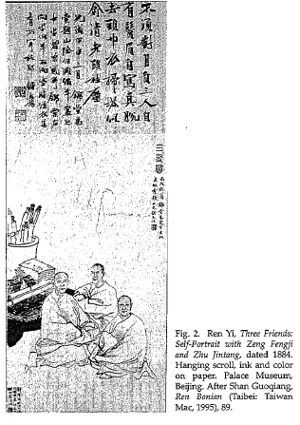
The Shanghai art shops came along the expansion in the economy, mostly in the port towns which changed the investment of art in the Qing dynasty regime. Shanghai which previously had insufficient artists abruptly became an extremely strategic dwelling for art activities and a cultural centre of south China. The interest of the Chinese in acquiring a culture lead to the initiation of countless antique and art shops to accumulate and trade antiques, and calligraphies and also paintings. The fan shops and additional Chinese panache art shops in Shanghai were newly fangled and clearly with modern progress. The society which existed in their art all moved to Shanghai to try selling their works. These artists outnumbered the natives of Shanghai although they did not change the three key ancient modes of making art, that is, direct contact amid the patron and artist, subsidiary approach over a common friend or even intermediate and the funding of a resident painter but rather engrossed the second and third of these functions. Therefore, this made them serve as both nonexclusive and a place to lodge artists.
During the first year of the Xuan tong reign, 109 art shops had been registered in the “Shanghai huashanghang mingle”, which is the record of Shanghai Chinese companies. This shows that the art shops had grown the Shanghai culture to a more modern and improved form of art. Proceeding to the Tongzhi reign, 1862-1874, more and more fan shops, mounting shops and antique shops were in trade. Shanghai developed suddenly and became vitally a strategic place for artwork and the cultural centre of southern China. Shanghai, therefore, drawn the responsiveness most artists who were non-refugees but had a profession in searching for customers.
These arts shops set up prices for artworks in Shanghai. The bond between the artists and patrons became more honest moneymakers as Xugu quantified in one of his poetries that in his rest he writes thousands of sheets of paintings which made his bread. This shows that most of the artists had thrived in the art business. The artwork advanced within a cultural range and the art shops reserved most of the local and traditional aspects. The social patterns of the artist staying at the dwelling at the art shop, for instance, the exclusive blend of the pre-modern settlements of the private investment and the newfangled viable structures. In a similar way, the art shops presented a communal galaxy for the unspecified, and even extended to overseas, patrons, and continually provided the essential goods and services for the community of Chinese.
THE REPUBLICAN ERA (1912-1949)

Jiang Feng, Revolutionary Printmaker, (wood art)
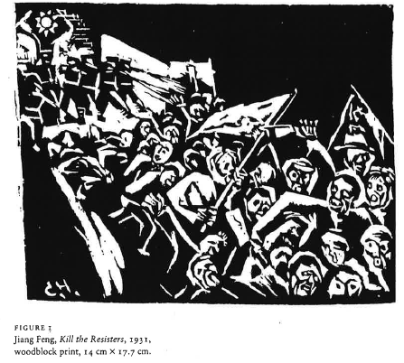
Jiang Feng, the printmaker, is a fascinating illustration of the radical artist who later developed a powerful bureaucrat beneath the new rule of Jiang Feng. This made a contribution to the leftist art. He was a woodcut artist and futurist in the pre-period, in the reign of the Jiang Feng which was anticipated as the dialectical characters in both of event spokesperson for art and of a radical optimist. This liberated the art from 1949 to 1957, an era which was basically the scheme of political control, administrative structure, and the technical and thematic plans of the new art which remained set in place.
During the period of Jiang Feng’s fundamental happenings in the metropolitan of Shanghai, the Red Army in the rural China established eight soviets, which after the attack of Nanjing, Beijing and Shanghai during the summer of the year 1937 by the Japanese fled to and the Japanese captured the shore region for the new communalist base at Yan’an, Shaanxi. Then Jiang Feng established one among of the early persisting art history and theoretic training in the similar year, a section of which he defined Lu Xuan’s upkeep of the radical woodcut program and even urged Lu Xun’s to advocate for the selective use of the old art forms so that new forms may be created. This forms a new form of art which bridges the gap between the art which existed during the literal Mao Zedong and Zhou Yang and the Chinese authors who brought the usage of native forms. The use of indigenous forms captured most of Lu Xun’s disciples who mostly believed much in China’s ancient fiction which was outdated and deficient in autocratic and radical essentials.
Lu Xun Academy main objective was to nature people in the practices and conceptual values of cultural advertising so that they possibly will be able to achieve the collaboration of indigenous people in the Communalist fighting campaigns counter to the Japanese. Their main difficulty was how they could reproduce imageries which could be understandable and acceptable by the huge uninformed rural people. Therefore, the European art of woodcuts of the ancient thirties was utilized, aiming at the diverse addressees but unfortunately weren’t essentially suitable for the new situation. This is for the reason that most of the artists who went to the Academy were city art scholars, hence were advised to take portion in the philosophical and practical training they went through beforehand being led to do the anti-Japanese advertising task. This enabled them to come up with more real techniques of communication with the labourers who could only understand the woodcuts artwork.
In any case, the main vulnerability was the way to change the complex high contrast woodcuts into work of art the country individuals may appreciate. This was settled amid the winter of 1939 and 1940. In December 1939, the socialist specialists discovered that the Japanese had made extremely imaginative and compelling utilization of the Chinese people print traditions in their own purposeful publicity. On print depended on the Chinese pictures of the lords of damnation and was known as the "Divine Retribution", which especially made them irate. The Chinese consequently chose to think of their own publicity pictures in the style of rural new year's prints. Using woodcut expressions as an extension between the provincial open and the Japanese, Jiang Feng appeared to have recouped all harms to his position brought about by the 1942-1943 battles. This mirrors the ability of craftsmanship in the successful end of the common war.
PERIOD OF GUIDANCE AND SUPPORT BY THE USSR- 1927 to 1953
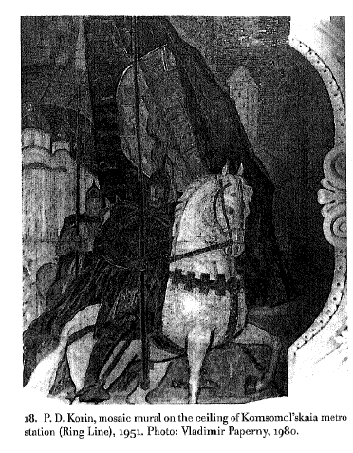
Korin Mosaic Mural on the Ceiling of Komsomol’s Kaia Metro Station
The metro in Moscow was opened in 1935 with a single 11 km line linking all the thirteen stations. The culture one comprised of the crematorium and burning as the main themes. The opening of Moscow Crematorium was naturally a heightened interest in cremation among the specialists and the populace. The Moscow Metro is said to have the most extravagant architectural projects of the USSR, though the station was created as a luxurious people’s palace. The aforementioned was build under Stalin command. Being an iron-fisted leader, Stalin ordered the metro’s artists and the architects to come up with a structure that could embody set and Sveloe bubushchee. Komsomolskaya was opened back in 1935. The mosaic mural was developed in the same year. Karin created this art to represent the Russian fight for freedom and independence.
Karin made the Architect of this era to prosper and to be well known. The roots of the station’s design can be traced back during in the early 1940s, which was drafted by Schusev. It was implemented in pure Petrine Baroque, which was a local adaptation of the Dutch Golden Age of the 17th century. However, the drafts were discarded after World War II and the stations of the Koltsev line were completed in the late Stalinist style of the period. Thus, Korin and others took over the baroque nonce order from Shchusev. In order to create the Mosaic Mural ceiling, Korin was inspired by Joseph Stalin’s speech at Moscow parade back in 1941. In the speech, the soldiers were inspired to avoid catastrophic loses in early World War II.
CULTURAL REVOLUTION ERA 1966-1976
Red Guard Art-1967
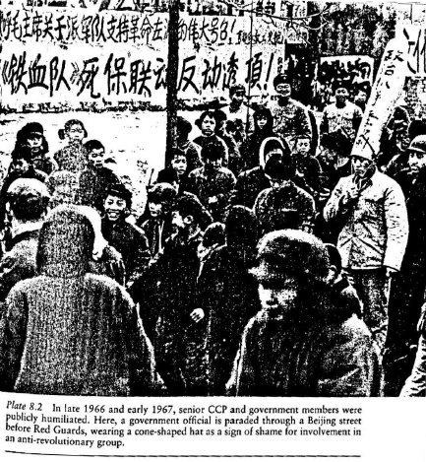
In China, the cultural revolution provided training for the artists for the third generation as well as painters. Most of these artists perceived that traditional Chinese Painting was outdated and the country needed new artwork in place. They thought that the new art was supposed to be including the representational work being based on human experience and practical concerns. In this Cultural revolution era, the Red Guard Movement emerged which was made to destroy the communist's party apparatus as well as dismantling the existing educational system. The early cultural revolution artworks were more like a parody of Chinese land reforms as well as thought reform movement of the late 40s’ and early ’50s of the 20th century. Red Guard art was formulated by Nie Yuanzi (Nieh Yuan-tzu). She developed it as a poster at Beijing University. In the poster, she argued that the cultural revolution was supposed to be a vigorous movement. She went ahead and denounced the administration of the Beijing University for restricting the movement and hindering its proper development. The poster fits the description of the cartoon that was designed by Weng Rulan. The version that was elaborated bear the title “A Crowd of Clown” which was issued by the transitory group of Red Guard. At the time, the art continued gaining more support from the municipal government complex which later on leads to the overthrow of the city government.
According to the Red Guard artist, the poster was made to display the first 39 high ranking bull’s eye of the cultural revolution. In the order in which they were purged by the government. She caricatured the figures in order to depict the political position and personal Quirks. The artist’s father was a professor of history and this builds her iconography to be able to discuss the issue of purged leaders with her dad’s allies. Most of these purged leaders spend most of their time home without doing anything. With the art, the artist was able to explain the significance of the purges to the young artists. Moreover, this gave her a hint of the best-recognized foibes of the leaders.
REFORM ERA -1978-2018
Zhu Xiao, he’s “Complex Writing and Ink paintings of the traditional beauty by Wu Yiming”

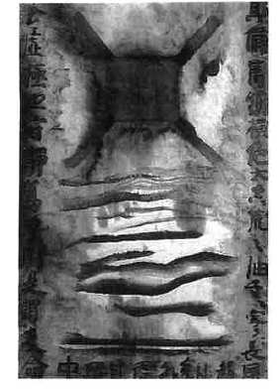
Zhu Xiaohe applies the style of “reading painting/ viewing poetry” as an approach to art, that is, by use of color and lines on canvas instead of engraving words on paper to interpret and read the painting including the ancient paintings such as the “Three Court Ladies” engraving works, “Education of the son” among others. He used a new painting which created traces by crowded colour lines ion the canvas. This was an extraordinary painting with elements of expression which were out of stroke and colour field. Zhu took part in the China/ Avant-Garde Exhibition which was held in Beijing in the year 1989. From this experience of this exhibition, Zhu began selecting more abstract short lines to use as his word elements in order to interpret the painting and make his hermeneutic paintings.
However, his paintings of short lines became non-specific without any direct images to refer to. The paintings which have been so far interpreted have been modified into reality such that it appears as a modification of the original reality. As Zhu expresses it, his writing/painting is not one which can be measured, expressed or whose purpose can be traced, but extends beyond a writing that overlaps another writing and generates another writing, one which gives birth to complex and small abstract layers of lines, making it impossible for recognition and easy representation. Therefore, it transcends the open, the dull and the simplified subject matter with the outer images becoming layers of the confused lines, obscuring images ab the writing keeping overlapping and dismantling without the ability to stop and draw a conclusion for the painting art.
Thereafter during this regime, there emerged Wu Liming from Shanghai who was a traditional Chinese painter. He produced a sequence of ink paintings of beauties who existed in the ancient costumes. He would make a draft of the picture, then make a contour to copy the original painting, then use the traditional ink washing technique to operate the multilayers to produce a blur on the contour and colours of the female figure. The final art was a result of picturing ancient beauty with the elimination of facial features and detailed patterns of clothes. Wu repeatedly experiences frequently the feeling of the “ages” as he was being unheated by his brushes. However, his paintings have a simplified, succinct traditional angle f view and purely beautiful in traditional visual art.
Li Hua sheng’s “Line – Diary”
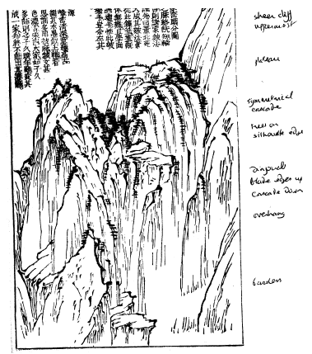
It was in recent years when Li produced a nice deal of abstract paintings using ink and wash. He was a Chinese painter, well versed in traditional literati painting. He surprised so many people with his artwork which was similar to the Minimalist style of the western. Li painted his lines short on the rice paper along the hidden lines, with the lines passing from top to bottom, or left to right. The lines were usually written out with controlled force focused on the tip of the brush instead of light touches or doing it without any consideration. The lines by Li cannot be understood without first comprehending the reason why Buddhist priest Hong Yi spend six minutes writing down only one Chinese character. This is because the process of moving a brush is usually very slow since the artist concentrates on the stylized appearance of the character or the line being drawn.
At some instances, Li could work on a single line so many times, such that the ink would soak into the little squares created by the intersection of the various lines and produce an unexpected appearance. He would also write down thick dots “seals” or some Chinese characters which are similar to the shape of seals on the hidden squares of the rice paper. These lines, characters and seals used to be written down slowly, in a scrupulous way with the artist paying full concentration, conditions which imitated the daily conditions for the activities of the Buddhist monks. On the other side, the monotonous and boring lines stood in part of the various and volatile traditional lines. Li arranged the traditional lines in an orderly manner especially those which existed since the Yuan and Ming Dynasties. This shows that Li was rational and orderly in the combination of the traditional culture and religious elements. Some of the spiritual lines had been fastened in the ink lines, which depicts strict control of temperament and dispelling the personality and expressiveness of an individual. However, the art lines do not express any elementary representation of elements. Li manages to avoid the use of inflammatory words as adjectives such as tonal, graceful and elegant.
CONCLUSION
Art is an activity which can be used effectively in the transmission of a person’s personal experience, emotions into others. In China, art has been used effectively by artists to express their experiences and emotions concerning religion, politics, war, and culture among many other aspects. From the above discussion, it is evident that art can the capability to transient cultural practices and beliefs of a community from their ancient and shift them and integrate them into various parts of the world and still maintain their identity. The Shanghai painting culture managed to spread to Japan, Tokyo and Osaka among other parts of the world through art, (Léger, 2012).
Art has played a huge role in fighting against the dominance of cultural differences, racism and other kinds of social segregation in an effective way. This is because any form of art is generated from human experience and emotions, which have an enriching experience in the artists and hence the audience ought to believe in the art. Therefore, art and artists have the ability to strengthen and push people to act in a certain way. This is the reason why artists have a significant contribution to the culture and politics of religion, community, country or even the globe since they have the ability to move people to act. Therefore, artists should be cautious on what to write and draw so that they may help the community integrate to more peace, economic growth and political advancement.

Reference
Andrews, Julia F., and Kuiyi Shen. The art of modern China. Univ of California Press, 2012.
Yeung, K. "A changing landscape: the integration of computer-generated mark-making and text with traditional Chinese ink painting." (2013).
Moise, Edwin E. Modern China. Routledge, 2013.
Davis, Walter B. "Art, Aesthetics, and Religion in Modern China." In Modern Chinese Religion II: 1850-2015 (2 vols), pp. 195-257. BRILL, 2016.
Cridge, Nerma. Drawing the Unbuildable: Seriality and Reproduction in Architecture. Routledge, 2015.
Li, Huayi, Zhiyuan Chen, Arjun Mukherjee, Bing Liu, and Jidong Shao. "Analyzing and detecting opinion spam on a large-scale dataset via temporal and spatial patterns." In ninth international AAAI conference on web and Social Media. 2015.
Léger, Marc James. Brave New Avant-Garde: Essays on Contemporary Art and Politics. John Hunt Publishing, 2012.
V. Paperny. ARCHITECTURE IN THE AGE OF STALIN CULTURE TWO. Cambridge University Press, (2002).

Andrews, Julia F., and Kuiyi Shen. The art of modern China. Univ of California Press, 2012.
Andrews, Julia F., and Kuiyi Shen. The art of modern China. Univ of California Press, 2012.
Cridge, Nerma. Drawing the Unbuildable: Seriality and Reproduction in Architecture. Routledge, 2015.
Yeung, K. "A changing landscape: the integration of computer-generated mark-making and text with traditional Chinese ink painting." (2013).
V. Paperny, (2002). ARCHITECTURE IN THE AGE OF STALIN CULTURE TWO. Cambridge University Press.
Moise, Edwin E. Modern China. Routledge, 2013.
Léger, Marc James. Brave New Avant-Garde: Essays on Contemporary Art and Politics. John Hunt Publishing, 2012.
Li, Huayi, Zhiyuan Chen, Arjun Mukherjee, Bing Liu, and Jidong Shao. "Analyzing and detecting opinion spam on a large-scale dataset via temporal and spatial patterns." In ninth international AAAI conference on web and Social Media. 2015.
Léger, Marc James. Brave New Avant-Garde: Essays on Contemporary Art and Politics. John Hunt Publishing, 2012.
Davis, Walter B. "Art, Aesthetics, and Religion in Modern China." In Modern Chinese Religion II: 1850-2015 (2 vols), pp. 195-257. BRILL, 2016.
Cridge, Nerma. Drawing the Unbuildable: Seriality and Reproduction in Architecture. Routledge, 2015.

